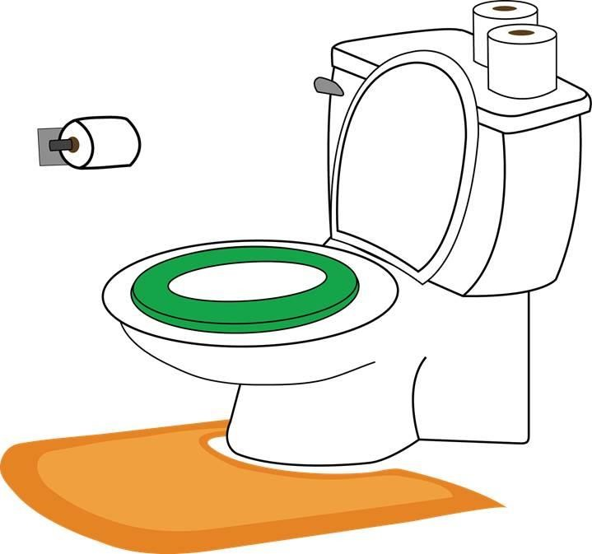

Potty Training
Sometimes I need to pee or poo. I have a feeling in my body when I need to pee or poo.
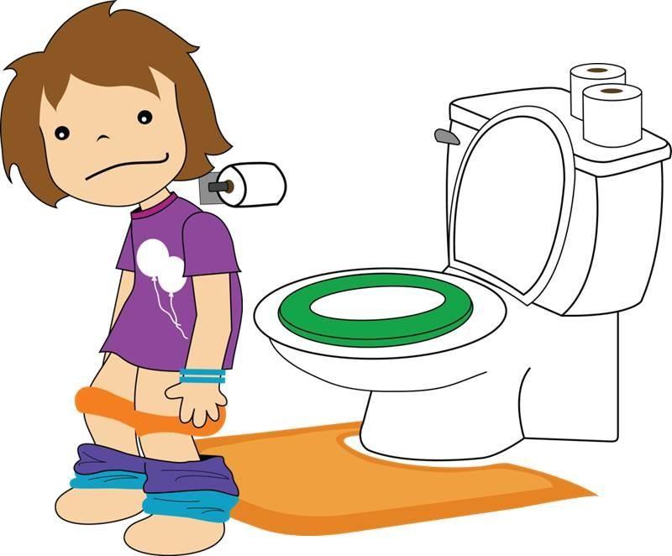When I feel like I have to pee or poo, I go to the bathroom. There I take down my pants and underpants.
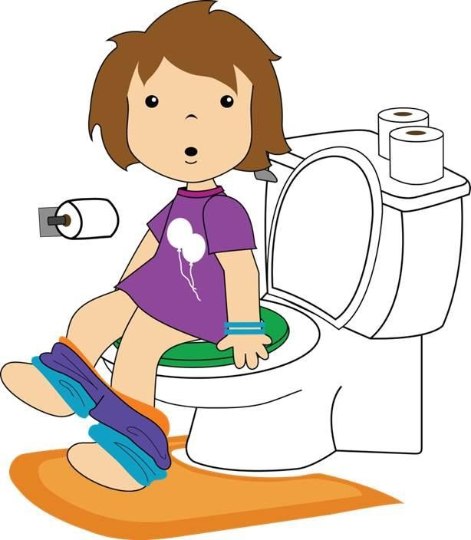I sit on the toilet. When I’m on the toilet I can go pee
or poo.
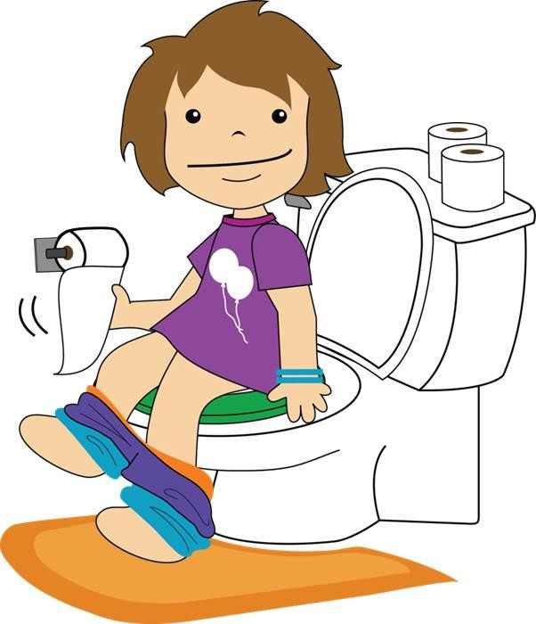After I make a poo in the toilet, I need to use toilet paper to wipe my bottom to keep my body clean. I can put the toilet paper in the toilet.
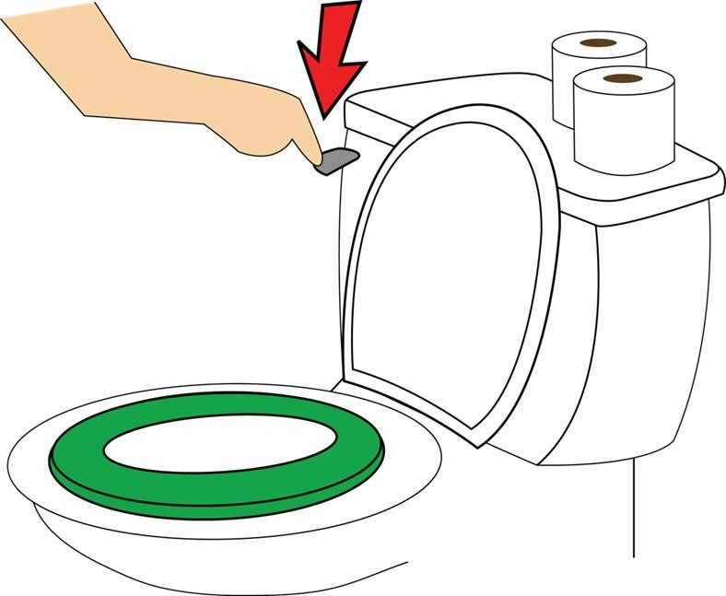After I pull my pants and underpants back up, I can flush the toilet.
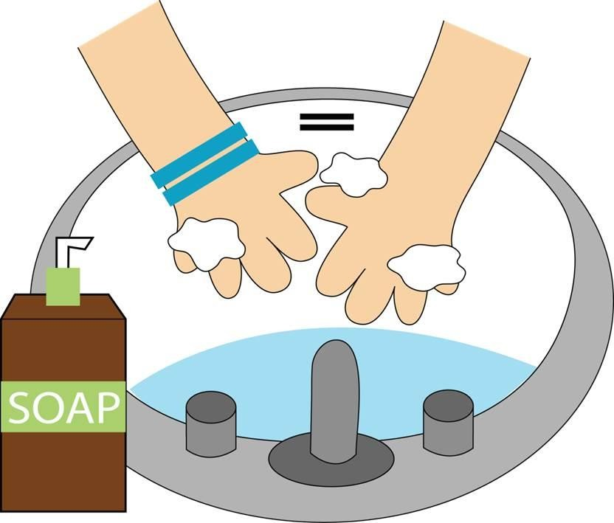After I pee or poo in the toilet, I need to wash my hands. Keeping my hands clean keeps me healthy.
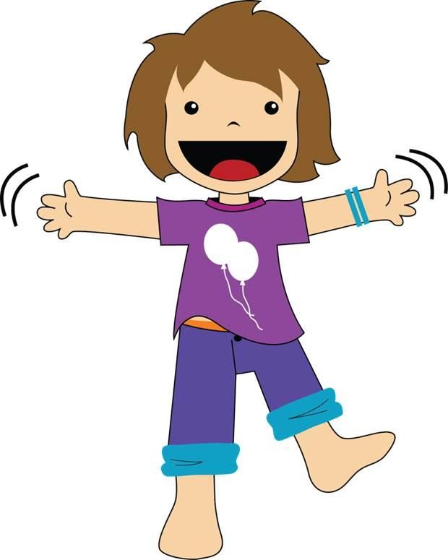When I go pee or poo in the toilet, I have clean underpants. That is great!
Sometimes I might have an accident. That is okay. I’ll
just keep practicing to make it to the toilet.
I can use the toilet. I’m so proud of myself!

