Vinner and VBoss – Product of Vidya Sagar
Vidya Sagar launched its own low cost, technology access device called Vinner and VBoss on March 28th, 2018.
In the past, Vidya Sagar has come up with a number of innovative technology devices where access to communication, education and leisure has been made possible. This has been done in partnership with IIT, Anna University and IISC, Bangalore.
In order to make such switches affordable and available to all, Ms.Nandhini Botta, an Electrical engineer working in the US made a simple prototype of these 2 devices and Vidya Sagar’s internal team later replicated them.
Vinner is a plug and play USB interface, and when VBoss is connected to Vinner, it takes the functionality of a left click of a mouse. With this, a person can access programs on computer and laptop which work on scan mode.
Some of the programs Vinner and VBoss have been used on- Board maker (in scan mode) for communication, Press to Play (scan mode) for games and also for shifting to the next slide in PowerPoint presentations.
Additionally, VBoss can be operated independently on toys and appliances (such as camera, scissors, torch, remote control etc.) that work on battery, with slight electrical modifications. The toys will operate with one tap of the switch and will stop when tapped again.
People who face challenges in using keyboard or mouse can VBoss for communication, learning, accessing computers.
Vinner and VBoss together cost
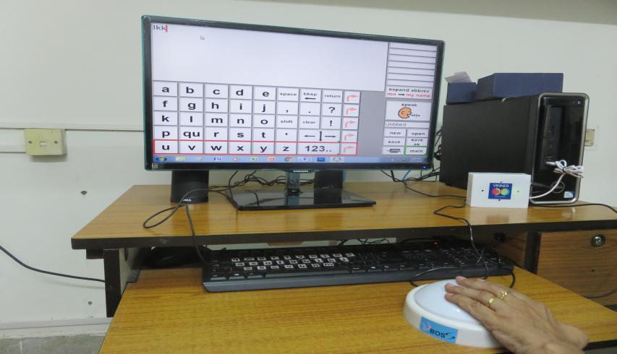

Rs.750.00
For further details, contact
Vidya Sagar
Email:
communication@vidyasagar.co.in
Ph: +91-44-22354784/85

